**Time and Time Management**

1. **Timeframes and schedules**

***‘Time is money’***, says the famous phrase. The **timescale** or **timeframe** is the overall period during which something should happen or be completed. The **lead time** is the period of time it takes to prepare and complete or deliver something.

The times or dates when things should happen is a **schedule** or **timetable**.

If work is completed at the planned time, it is **on schedule**; completion before the planned time is **ahead of schedule** and later **is behind schedule**. If it happens later than planned it is **delayed**; there is a **delay**. If you then try to go faster, you try to **make up time**. But things always **take longer than planned**.

A period when a machine or computer cannot be used because it is not working is **downtime**.

1. **Projects and project management**

Project: a carefully planned piece of work to produce something new.

We usually use Gantt chart when planning.

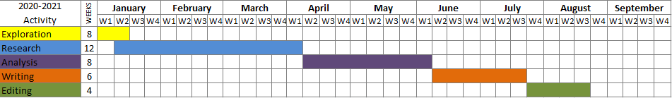

The exploration stage and the Research stage **overlap.**

There are no **simultaneous** works: nothing **runs in parallel**.

Project management: bonus payments for **completion on time**, penalties for **late completion**.

1. **Time tips:**

* Use a diary (BrE) or a calendar (AmE) to plan your day and week. Personal organizers (small pocket-size computers) are good for this.
* Plan your day in advance. Make a realistic plan in order of importance: prioritize them.
* Avoid interruptions and distractions
* Try to balance time cost and quality.
* **This is what actually happened in the building of the supermarket. Build up the Gantt chart based on the information given in the paragraph below.**
* The overall lead time was originally 12 months, but the project took 17 months. It started on time in June, but site preparation took longer than planned because of very bad weather in the autumn. Site preparation and building the walls should have overlapped, but the walls were started in January. We were able to make up a bit of time on the roof: it took two months instead of three, but we were still behind schedule. The next stage was fitting out the supermarket, but there was an electricians’ strike, so there were delays here too. The store opened in October, but now there’s a lot of downtime, when the computers don’t work.

|  |  |  |  |  |  |  |  |  |  |  |  |  |  |  |  |  |  |
| --- | --- | --- | --- | --- | --- | --- | --- | --- | --- | --- | --- | --- | --- | --- | --- | --- | --- |
|  | **J** | **J** | **A** | **S** | **O** | **N** | **D** | **J** | **F** | **M** | **A** | **M** | **J** | **J** | **A** | **S** | **O** |
| **Prepare site** |  |  |  |  |  |  |  |  |  |  |  |  |  |  |  |  |  |
| **Build walls** |  |  |  |  |  |  |  |  |  |  |  |  |  |  |  |  |  |
| **Build roof** |  |  |  |  |  |  |  |  |  |  |  |  |  |  |  |  |  |
| **Fitting out** |  |  |  |  |  |  |  |  |  |  |  |  |  |  |  |  |  |
| **Finish site** |  |  |  |  |  |  |  |  |  |  |  |  |  |  |  |  |  |
| **Recruit employee** |  |  |  |  |  |  |  |  |  |  |  |  |  |  |  |  |  |
| **Opening** |  |  |  |  |  |  |  |  |  |  |  |  |  |  |  |  |  |